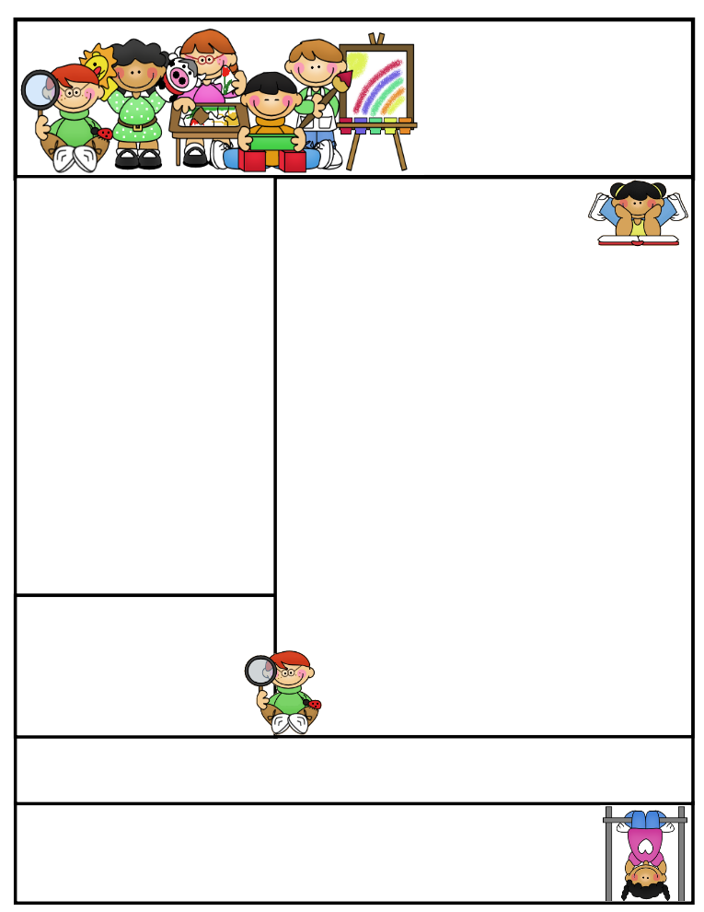

The **roots** of education are **bitter**, but the **fruit** is **sweet.** **Aristotle**

Mrs. Ahrens  
Newsletter

March 25th-29th, 2019

Mrs. Linda Ahrens Email address: lahrens@pleasantviewr6.org  
Pleasant View R6 Webpage: mrsahrens.weebly.com  
128 SE 20th Street Trenton, MO 64683

(660) 359-3438

Birthdays

Important Dates

Return the copy of grade card if you have not already.

T-shirts due by the 29th

Pirates the Musical

April 5th

Classroom News

White t-shirts are due to school by Friday, March 29th so we can tie-dye them for our trip to the zoo.

Parents are welcome to attend, but will need to notify me so we can make accommodations. This trip will occur on May 1st. More information about the trip will be coming soon. Please note this is a school day and if your child is not present, they will be counted absent and homework will be assigned for the day, which will be graded and recorded in the book.

Field trips are very expensive. This is why we raise money in Community Club. Tickets are also purchased ahead of time. I am only mentioning this since a few of your children have said to me they were not going.

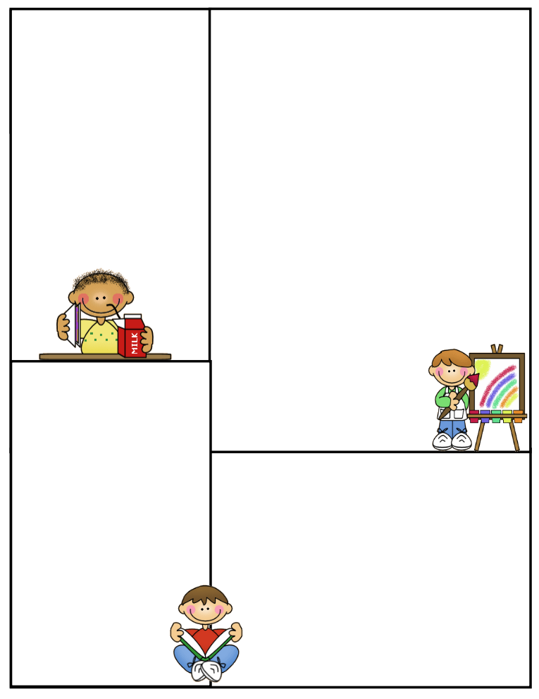

C.E.O.

Chief Example of Others

Spelling and High Frequency Words

**High Frequency Words (HFW)**--- found, hard, near, woman, would, write clever, signal

**Spelling Words**—long e: y, ey key, sandy, bumpy, my, puppy, night, funny, wash, penny, would

**Vocabulary Words**- advice, career, remarkable, soothe, trust

Lunch Menu

Monday: Pigs in a Blanket

Tuesday: Pulled Pork

Wednesday: Chicken and Noodles

Thursday: Hot Ham and Cheese

Friday: Meatloaf

What We’re Learning

Reading: This area also includes phonemic awareness, phonics, spelling and vocabulary. Spelling Words and high frequency words will be listed at the bottom of this page. Phonemic Awareness: long e: y, ey

Literature Stories Ming’s Teacher From Puppy to Guide Dog Koko and Penny Saving Mountain Gorillas

Math: Counting nickels and pennies, order events by time

Writing: Adverbs that Tell When Mechanics: Commas in a series

Science: Down in the Dirt and Earth Day

Social Studies: Taking Pictures